***USE STRAW BALES***

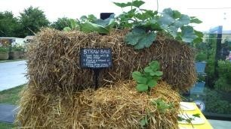 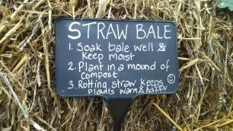 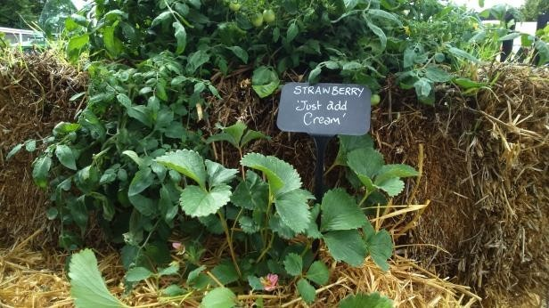

This is an idea I’d like to try out on my allotment next year

This is a new one on me, although I have heard of straw bales being used at the allotment to create hotbeds. Juliet has planted strawberries and melons in compost within the straw bales. I particularly liked the melon ‘Ogen’ which is grafted onto courgette root stock so that it can tolerate the UK climate better. Seeds can even be sown onto bales if a 5cm layer of compost is added first and with the extra heat created, crops like melons are more likely to be successful on straw than in the ground. The only concern I’d have about using straw bales is the possibility of herbicides or in the straw. One solution would be to use organic straw or to investigate the provenance of your material before you use it.